**Financial Complaints KPI Dashboard**

In this project we creating the Financial complaint KPI dashboard. This is business dashboard, so we need to understand the dada and its structure for better visualization. Now, we need to connect data source for visualization

According to data we need to show total complaints.

Create new sheet – **TOTAL COMPALINTS**

Column- date submitted – (In Month)

Row – Financial consumer complaint (FCC)

Hold FCC (ctrl+ drag) drag into colour then remove axis line format grid

Create new calculated filed – Total complaints

{Fixed : Count([Complaint ID])}

Drag Total complaints into details

Then double click on title – click on insert – insert Total complaints – edit it according our requirement

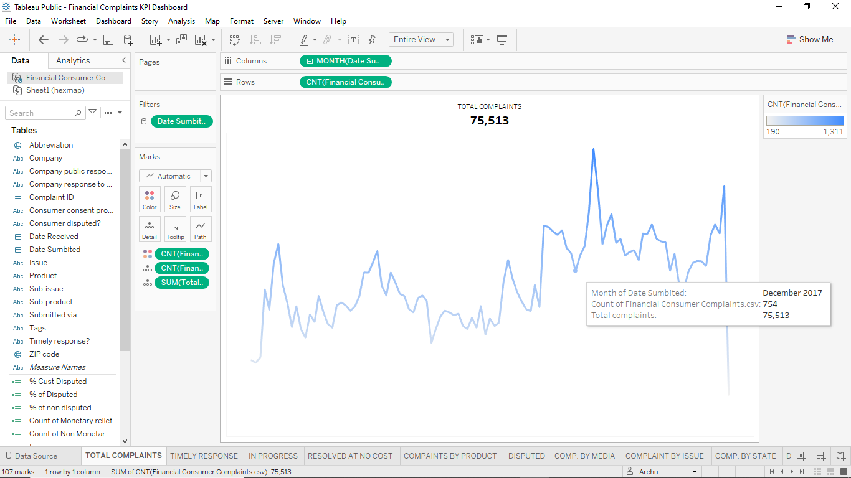

New Sheet – **Timely Response Rate**

Create new calculated field – Timely response in %

COUNT (if [Timely response?] = "Yes" THEN [Complaint ID] END) / COUNT ([Complaint ID])

Drag n drop Timely response? Into details

Double click on title edit it and click on insert - Timely response in % - edit it

In Details -RC on AGG(Timely response?) go to the format – Pane – number- percentage – 1

Create new calculated field - Non Timely response

1-[Timely Response in %]

Drag n drop measure value on column, keep only timely n non timely response remove remaining field

Then putting it as a bar then put measure name on colour then change the colour as u want

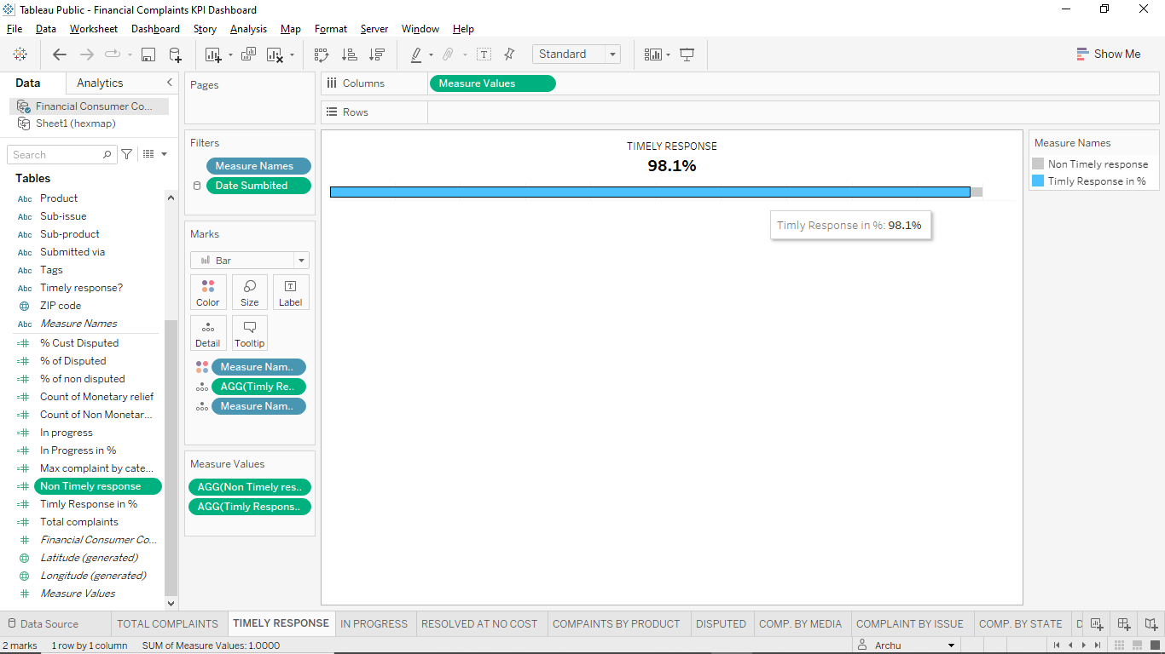

New Sheet – **In Progress**

Create new calculated field - In progress

COUNT ( IF [Company response to consumer] = "In progress" THEN [Complaint ID] END )

Then put In progress on Details –

Double click on title insert In progress edit it

Then once again create new filed - In Progress in %

[In progress] / COUNT ([Complaint ID])

Put In Progress in % on Text edit it , select proper position

Then RC on In Progress in % - format- Pane- Number – Percentage - 2

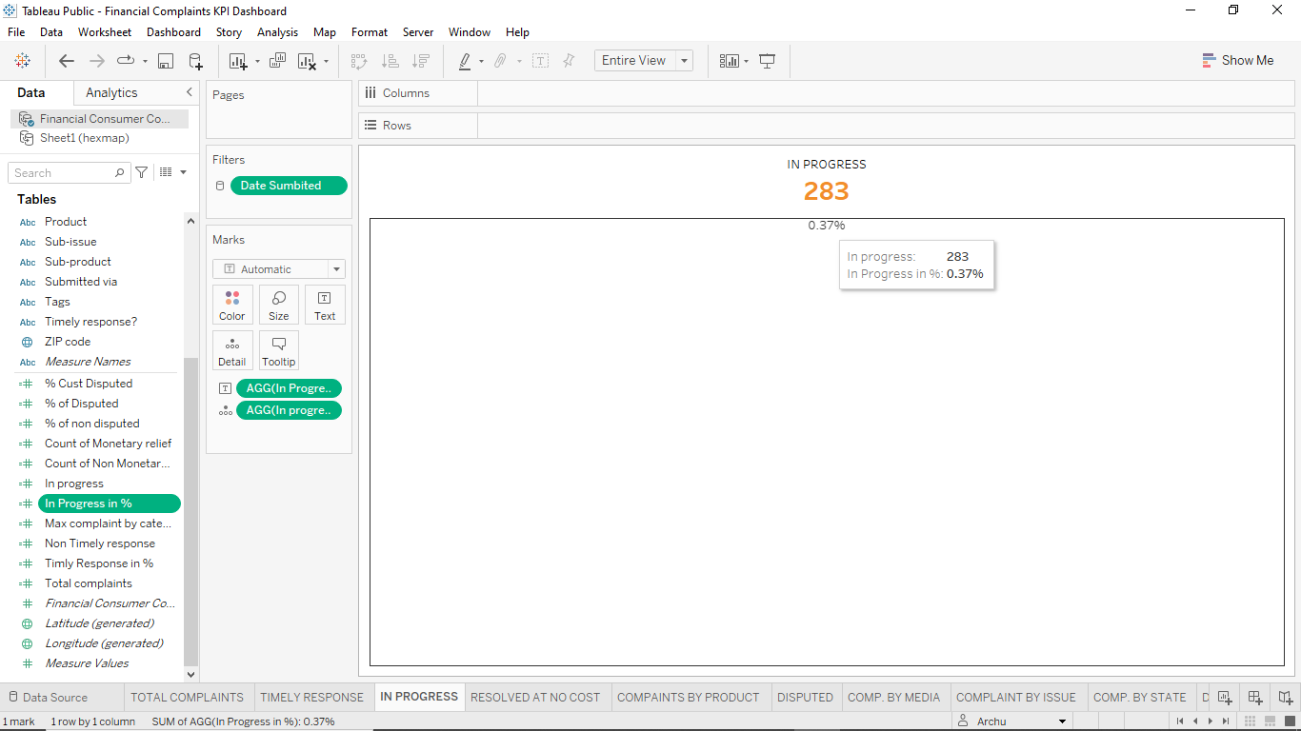

Create new Sheet- Resolve At No Cost

Create new calculated field - Count of Monetary relief

COUNT( IF [Company response to consumer] = "Closed with monetary relief" THEN

[Complaint ID] END)/ COUNT([Complaint ID])

Create new calculated field – Count of Non Monetary relief

1 - [Count of Monetary relief]

Put Count of Non Monetary relief on details – RC- Format- change number into percentage – 1

Edit Title – insert Count of Non Monetary relief

Bring measure value in column – keep only Monetary n Non Monetary relief

Change bar instead of automatic Put measure name on colour – select colour as u want

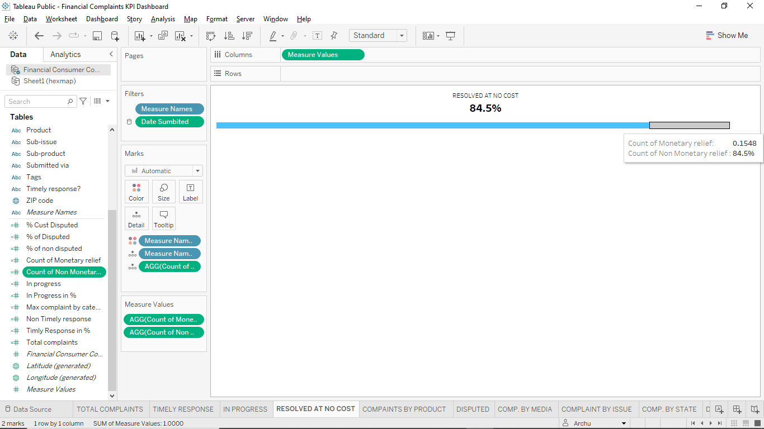

Create new sheet- Complaint By Product Edit it

Column= FCC

Row= Product

Sort it to descending then edit the bar chart according to u

Select proper colour, set the size, remove the grid from format, hide axis

Click on TEXT – check the show labels mark- edit it

Draw the average Line on Bar

Go to Analytics – Average Line – put it on table – RC on The Line – Edit – reduce size change colour, change pattern _ _ _

RC on the Avg Line – format- Line – choose colour and 49 %

If u want to show AVG value on chart so,

R C on Average – Edit - Label -custom -Average- choose<Value>

RC on AVG number (9.145) go to the format – number – set decimal place =0

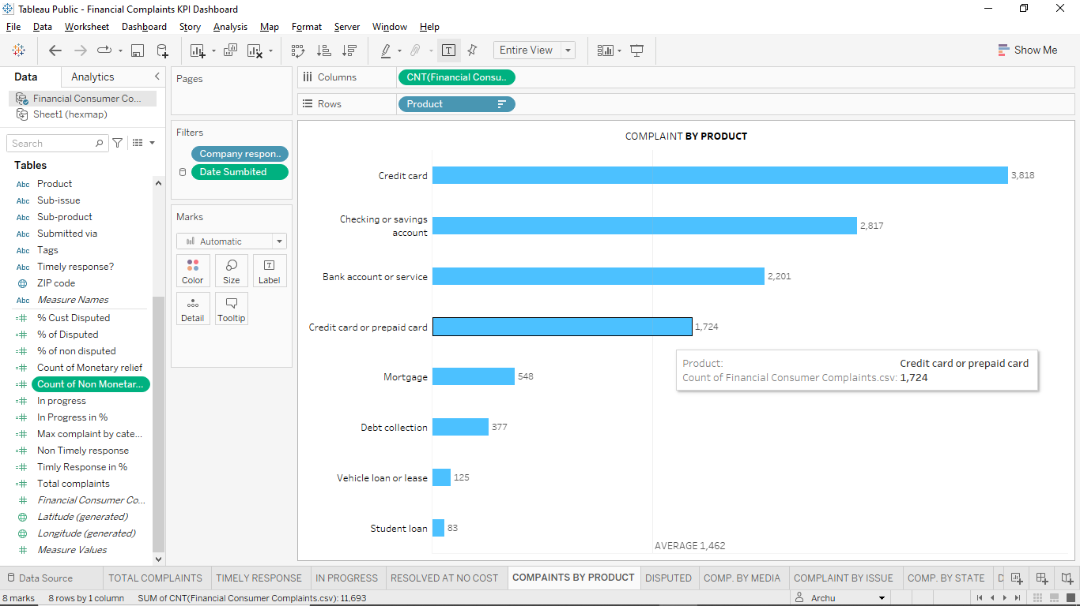

Create new sheet= Disputed

New cal Field= % Cust Disputed

COUNT( if [Consumer disputed?] = "Yes" THEN [Complaint ID] END ) / COUNT([Complaint ID])

Select Pie instead of Automatic then drag n drop FCC on Angle

Put Consumer Disputed on Colour

Now we need to create dual axis so on column= min (0) once again write min(0)

Then edit both pie chart as you want, remove all field from second chart set colour white, reduce its size, then R click on second min(0) – select Dual axis then click on Text - check Show Label – set alignment

After that put FCC on Label -RC- Quick table calculation- percent of Total

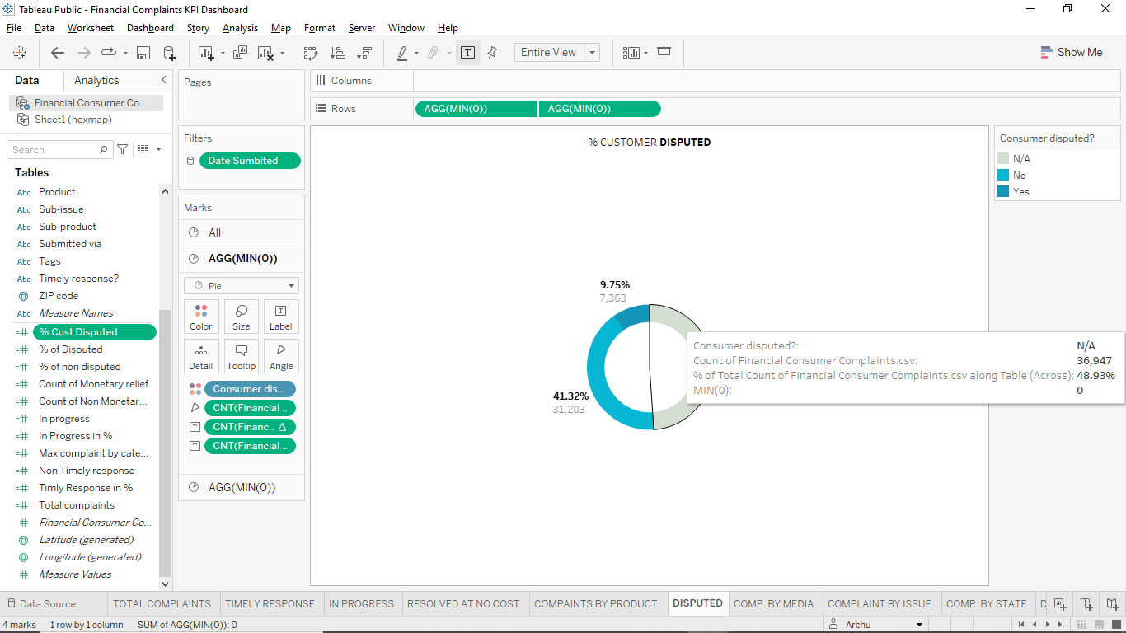

Create new sheet – Complaint BY Media

Columns= FCC

Rows= Submitted Via set descending order

After that add Measure value into column remove all field keep only Agg(FCC) or add sum(0)

Then RC on Measure Value select Dual Axis, synchronize the axis

on Measure Value filter select line instead of automatic, put Measure name on path then we get lollipop chart

then we adjust the size of lines and circle after that set colour to both

than format and edit all thing as per our requirement

then put FCC on label in Measure Value filter change it to the percentage ,once again add FCC into label then set proper alignment n edit size

then go to FCC filter go to Tooltips then edit it

Submitted via: **<Submitted via>**

Count of Financial Consumer Complaints.csv:**<CNT(Financial Consumer Complaints.csv)>(<% of Total CNT(Financial Consumer Complaints.csv)>)**

Then Copy all the content as above paste it into Measure Value filter tooltips

Then put FCC and Measure value on details In Measure Value filter

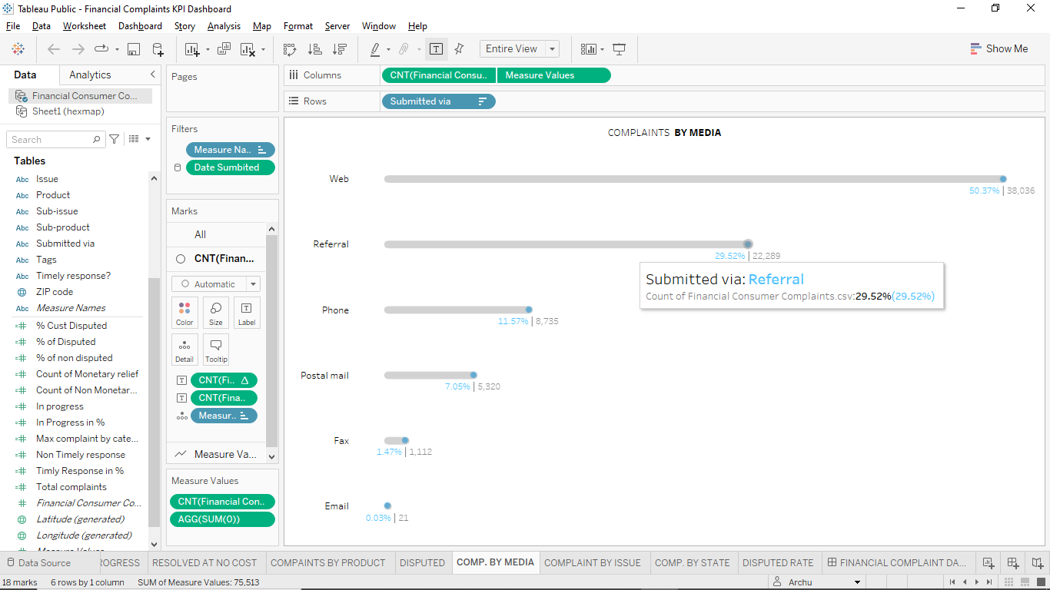

New sheet= Complaint by Issue

Column= FCC

Row = Issue Descending it

New Calculated Field = Max complaint by categories

{ FIXED : MAX({FIXED [Issue]: COUNT([Complaint ID])})}

Then add measure values on column keep only FCC and add sum(0)

In measure values filter change Automatic into Line

Hold measure name into path increase size

In FCC filter set it to bar, reduce size of bar

Then select Dual axis from measure values

Assign proper colour font and all

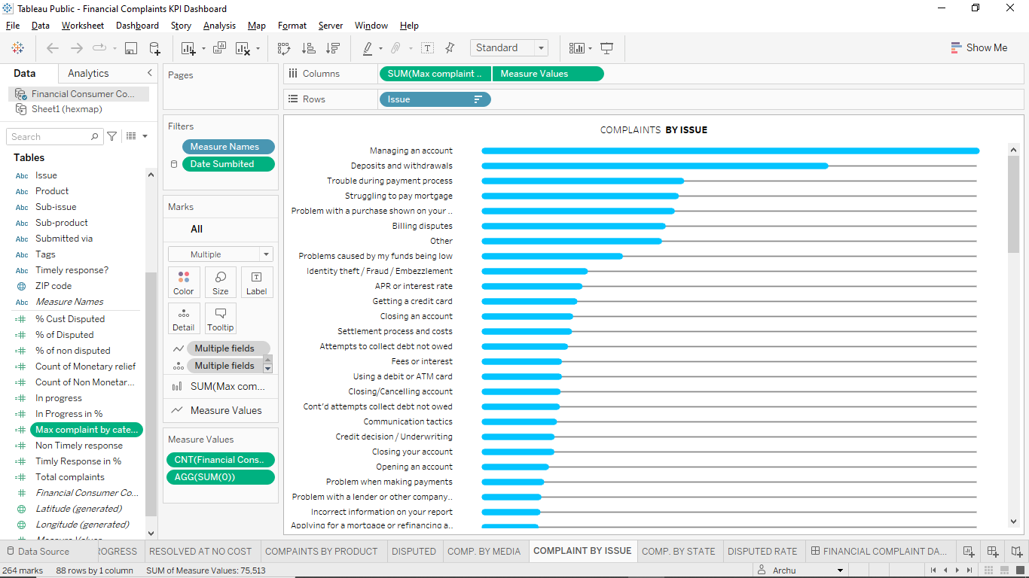

Create new sheet = Disputed Rate its similar To resolve at no cost

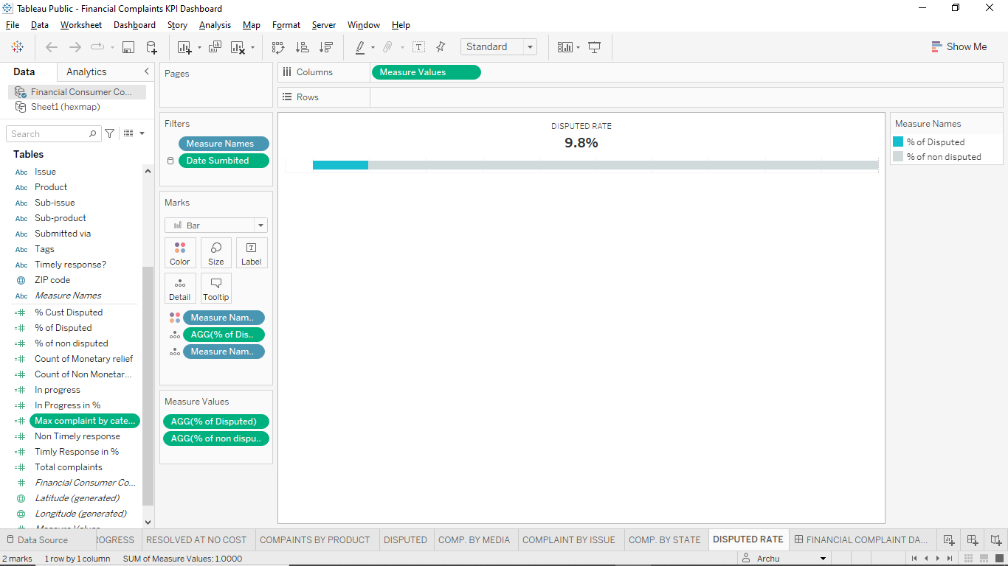

Create new sheet = complaint by State

Download new Hexagon shape and excel file from <https://www.sirvizalot.com/> website

After that add new data source into our dashboard add that excel file

Now change the state field name into Abbreviation (because new data set column abbreviation and old source column name state has same value)

Now drag row on row and columns on columns from new data source

Then click on analysis(toolbar) click on aggregate the measures

Now click on roe axis click on edit axis then select reverse

Now put Abbreviation on label choose hexagon shape (that we downloaded ) increase size

Then set colour alignment centre(verticle)

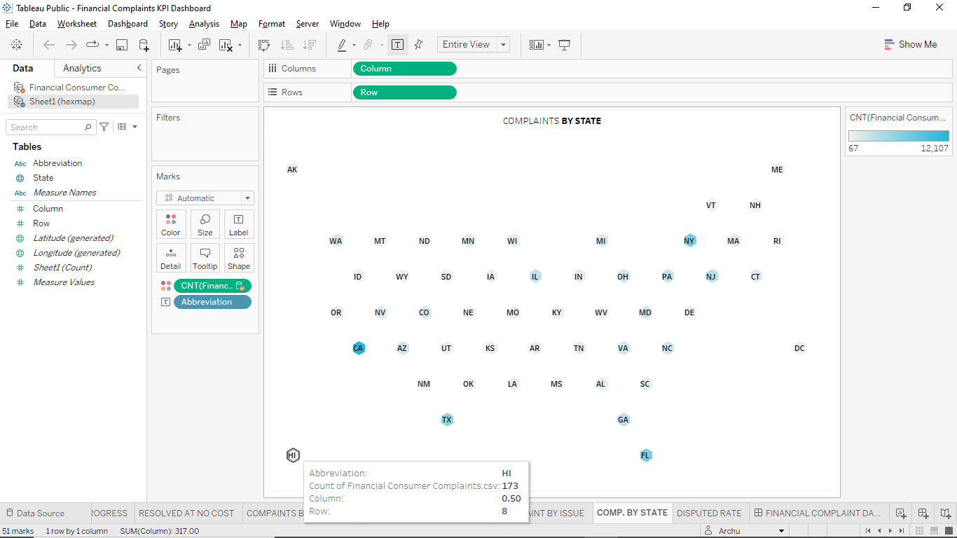

Now create the dashboard= Financial Complaints KPI Dashboard

Add date submitted field into filter of complaint by issue

